**1. Introduction**

1.1 Introduction

In Sri Lanka students in their final collegiate year (age 18-19) sits for General Certificate of Education (Advanced Level). Each year over 240,000 students qualify to sit for the G.C.E (Advanced Level) exams. This exam assists as an entrance requirement for many Sri Lankan state universities and many other universities. The students are expected to study two years in school before participating for the exams. The exams are conducted in three languages Sinhala, English and Tamil and diverse over four fields (Math, Science, Commerce, Art, and Technology). Each student must choose three subjects under one field. According to the University Grant Commission Sri Lanka, in 2017, only 19.25% of qualified candidates were admitted to undergraduate courses, The percentage slightly decrease to 18.98% in 2018.In 2019, it increased to 22.98%. Its further increase reaching 22.58% in 2020 and 25.39% in 2021.

Figure 1- (Sri Lanka University Statistics 2022, 2022)

The above statistics showcase the intense competition for this examination among students each year.

Among all the General Certificate of Education (Advanced Level) subjects, the project discussed in this report emphases exclusively on the subject chemistry. Students of both bio science and physical science sits for the chemistry paper. Annually, approximately 75,000 students sit for the G.C.E (Advanced Level) Chemistry exam. In 2021, 76,851 sits for the exam and shows 29.58% failed percentage, in 2022, 75,612 students sat for the exam and 28.80% failed the exam. The exam for the subject chemistry involves two papers. Paper one and paper two are held on two days, paper one prior to paper two. The first paper consists of 50 MCQs (Multiple Choice Questions) that contributes 50 marks directly to the final grading of the subject. The second paper consists of 4 structured questions and 4 essay questions that carries total 1000 marks which will be later taken out of 50 marks. The 50 MCQs on the paper 1 can be categorized in to five categories as inorganic, organic, environmental & industrial, physical, and general chemistry. As mentioned before the first paper is held prior to paper two and carries 50 marks directly to the final grading. Hence the students are keen on scoring more on paper one to secure their results early and more easily.

Students that sit for the exam, quizzes themselves using MCQ past paper questions and model paper questions with improving paper 1 results in mind. Often students attend to private tutors for this but to achieve better results self-studying is unavoidable. Thought self-studying plays a crucial role in improving one’s result, without proper guidance this may not be effective.

1.2 Problem Definition

As previously mentioned, the paper 1 of chemistry exam consists of questions from five subject areas (Organic chemistry, Inorganic chemistry, Physical chemistry, Environmental & Industrial and General chemistry). Many students engage in answering more mcq questions to recognize the subject areas they lack knowledge in and excel in. By identifying these areas they’ll be able to grasp what subject matters that need more of their attention. Though tutors provide some assistance in recognizing these subject areas, the onus of improving the knowledge on subject matters clearly lies on the students themselves. The process of recognizing subject areas that need more attention tend to be time consuming but pivotal. Recognizing the areas, they lack knowledge affect directly to the performance enhancement process. This helps students to fill their knowledge gaps and improve understanding. Likewise, if the students are well prepared for the exam, the stress and anxiety they feel will be reduced facilitating optimal performance in the exam. Often students go through around 5-6 amount papers to recognize these subject areas. After recognizing, students tend to practice themselves with questions from those lacking areas. For this they either manually filter those subject questions from past papers or search for books that has subject vise categorized questions in them. Both methods can be time consuming. Time is precious for these students as they have two more subject that need the same amount attention and self-studying.

In conclusion, its crystal clear that to address these challenges an online platform that carter students need is required. A platform that offers a diverse number of questions in each subject category, can recognize the students’ weak areas efficiently and connect teachers and students when the students need further guidance. Hence, the platform discussed here intentions to improve the overall learning experience of students and academic performances.

1.3 Project Objectives

1. Building up confidence in students when solving exam questions.
2. Recognizing the areas where students excel and struggle in when answering questions.
3. Creating a question bank with questions from all the categories.
4. Help students to improve the effectiveness of their self-studying time.
5. Help students to manage time in their studies.
6. Provide students with instant feedbacks.
7. Help students to access different model questions from different tutors.
8. Help students to reach and get feedback from peers and teachers anytime they want.
9. To assist students in tracking their progress with each round of questions.
10. Developing a user-friendly/ easy to use platform for both students and teachers.
11. Helps teachers to reach out to students more often and check on their progress.
12. Facilitates students with continuously growing question bank.
13. Encouraging collaboration between students and teachers through the chat feature.
14. Helps teachers to improve their teaching skills.
15. Create an online community where chemistry questions can be discussed.
16. This project can be used as a blueprint in creating MCQ applications for other subjects.

**2. System Analysis**

2.1 Facts Gathering Techniques

Two types of data were gathered during the phase of fact gathering. Primary data was gathered using interviews and questioners and secondary data was gathered using existing systems and research papers. For this project online questioners were used to gather data from school students.

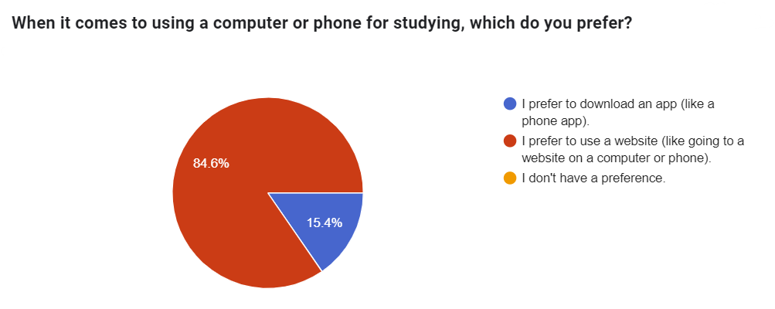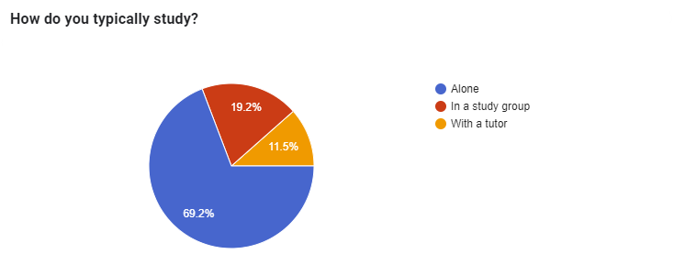

Shown above are the questionnaire and its analysis. Through the online questioner it was proven that in general most of the students tend to study alone. This data concludes that it’s crucial for the project focuses on helping students that study alone. When asked what’s the preferred tool used to help studying the majority choose the web applications while the others choose using mobile applications. This data on the preferred studying tool helps to develop the project in students preferred application type.

This highlights the use of technology with school students for their studies. Also stresses the need for an adoptive, user-friendly educational platform for students that provides an effective learning environment. In conclusion the analysis underscores the growing use of technology in the education sector, which is a good sign for the development of this project.

2.2 Existing System

2.3 Use case diagram

2.4 Drawbacks of the existing system

**3. Requirements Specification**

3.1 Functional Requirements

3.2 Non-Functional Requirements

3.3 Hardware / Software Requirements

**4. Feasibility Study**

4.1 Operational Feasibility

4.2 Technical Feasibility

4.3 Outline Budget

**5. System Architecture**

5.1 Class Diagram of Proposed System

5.2 ER Diagram

5.3 High-level Architectural Diagram

5.4 Networking Diagram (Optional)

**6. Development Tools and Technologies**

6.1 Development Methodology

6.2 Programming Languages and Tools

6.3 Third Party Components and Libraries

6.4 Algorithms

**7.Discussion [Max of 1 Page]**

Overview of the Interim Report

Summary of the Report

Challenges Faced

Future Plans / Upcoming Work

**8.References**

1. Administrator (2022). Sri Lanka University Statistics 2022. [online] Ugc.ac.lk. Available at: [https://www.ugc.ac.lk/downloads/statistics/stat_2022/Chapter%202.pdf](https://www.ugc.ac.lk/downloads/statistics/stat_2022/Chapter%202.pdf%20) [Accessed 23 Feb. 2024].
2. Anon, (2022). Performance of Candidates G.C.E.(A/L) Examination – 2022 (2023). [online] Available at: <https://doenets.lk/images/resources/STAT/final%20POC-AL-2022-web_1694447239752.pdf.>
3. Anon, (2021). Performance of Candidates G.C.E.(A/L) Examination – 2021. [online] Available at: <https://doenets.lk/images/resources/STAT/AL2021POC-Rev-1_1671814563246.pdf.>
4. ‌
5. ‌

‌